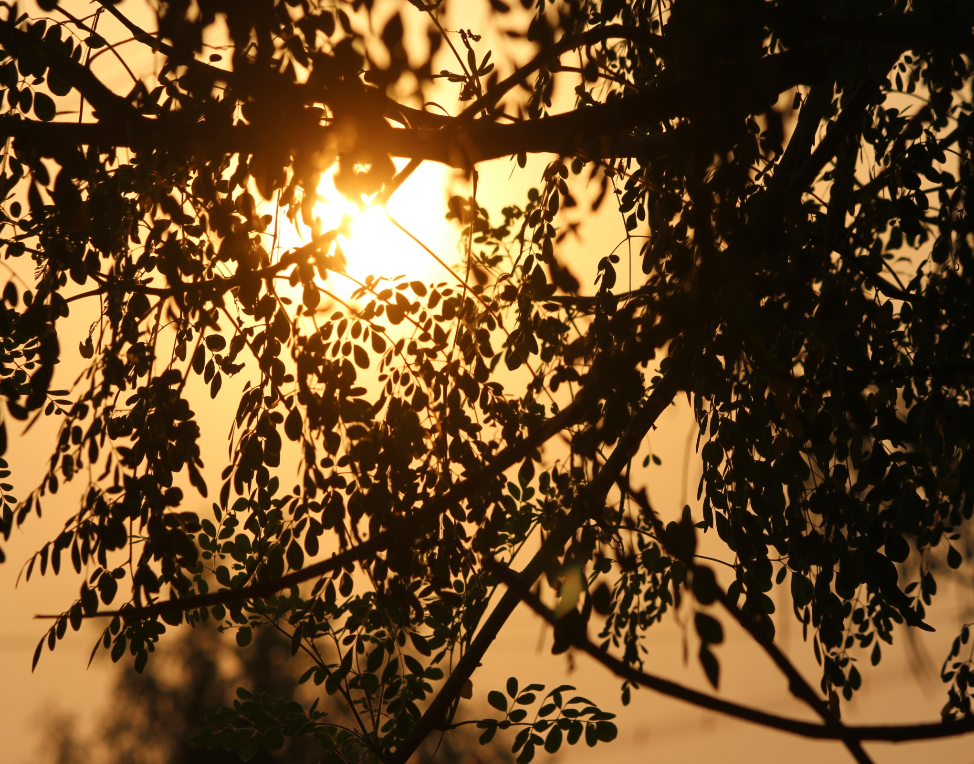**zzzzzzzz**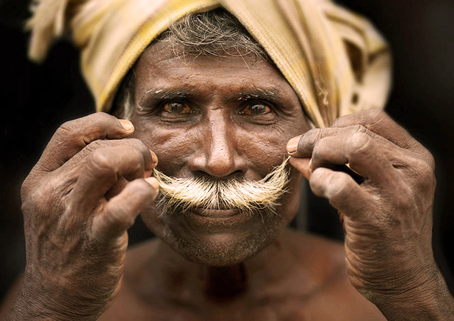

FIELD STUDIES

THIRUMALPUR

**INDEX**

|  |  |  |
| --- | --- | --- |
| S.NO. | TOPIC | Pg. No. |
| 1 | Executive summary | 4 |
| 2 | Introduction | 5 |
| 3 | Analysis of the macro environment | 7 |
| 4 | Products made | 22 |
| 5 | Type of weavers | 25 |
| 6 | Cooperative society | 26 |
| 7 | Process of receiving the order | 28 |
| 8 | Tools and infrastructure used | 30 |
| 9 | Process of weaving | 35 |
| 10 | Motifs and designs | 38 |
| 11 | Border and pallu | 45 |
| 12 | Waste management | 46 |
| 13 | Costing of the product | 47 |
| 14 | Problems and issues faced by the weavers | 48 |
| 15 | Profiles and surveys | 51 |
| 16 | Financial aid | 56 |
| 17 | Swot analysis | 57 |
| 18 | References | 61 |

|  |  |  |
| --- | --- | --- |
| Fig. No. | TOPIC | Pg. No. |
| 1 | Shree Manigandeshwarar temple | 5 |
| 2 | Villagers wearing shirts provided by party workers during elections | 8 |
| 3 | House built by the government for the villagers | 9 |
| 4 | Children at the government school | 10 |
| 5 | A woman tying yarns together, a very time taking process | 11 |
| 6 | People sitting on the thinnai and eating together as they socialize | 12 |
| 7 | A shop owner | 14 |
| 8 | Thinnai in a traditional house | 17 |
| 9 | The gears of a powerloom | 19 |
| 10 | A lady driving a scooty with her son | 20 |
| 11 | Waste dumped near the trees | 21 |
| 12 | Pillaiyar Towel ( left ), Janthar saree ( middle ) and Silk Saree ( right ) | 23 |
| 13 | Machine used for preparing the warp beam | 31 |
| 14 | Children returning from school | 57 |
| 15 | A girl sitting outside her house sunk in deep thoughts | 59 |

1. **EXECUTIVE SUMMARY:**

Field studies deals with the knowledge of the cultural, economical, social, political and other factors that directly or indirectly help in shaping the place.

The study which we carried out was in two sets, one that formed the primary data which was collected by surveying the area, interacting with the locals and the visitors. The other set consists of the information which is gathered about that place through published literature material.

Our area of study was Thirumalpur. It is a town situated in Nemili Block of Vellore district in Tamil Nadu. Located in urban part of Vellore district of Tamil Nadu, it is one of the towns of Nemili Block of Vellore district. As per the administration register, the town number of Thirumalpur is 630691. The town has 1159 families.

The weavers of Thirumalpur worked under the government previously before private societies from Kanchipuram who provide raw materials and get labour in exchange. Most families in the Thirumalpur have power looms that manufacture cotton- polyester sarees, where cotton is the warp and polyester in the weft, these families get 750 units of power for free from the government, the machine on an average is 10 years old and is bought by the investment of the weavers, nowadays the government is also providing power looms at a subsidised rate but it isn’t of good quality.

Our area of study mainly deals with weaving. We started our survey with the data collection of our macro environment, i.e. observing the location, and further interrogated and surveyed the micro environment of the place.

The collection of data and face to face commutative interactions with the people and residents of Thirumalpur helped us to find out not only the functioning of the looms but all the other factors related to the growth, hygiene and several other issues of the place.

While completing this project we learned how to plan the research and while working on the field we got to know the actual differences. We learned how to execute the plans. After this project, now we know that it is the initial idea that forms the foundation of everything that is executed and earned.

Thirumalpur is a village situated in between Kancheepuram and Arakkonam, 20 kms away from Kancheepuram and 20 kms. away from Arakkonam of Vellore district. The total population of Thirumalpur is 5000. 90% of weavers belong to weavers community i.e Senguntha Mudaliyar and remaining 10% are from Yadavas, SC and Christian etc. The main profession of place is weaving. All are independent weavers.

1. **INTRODUCTION**

2.1 HISTORY OF THIRUMALPUR:

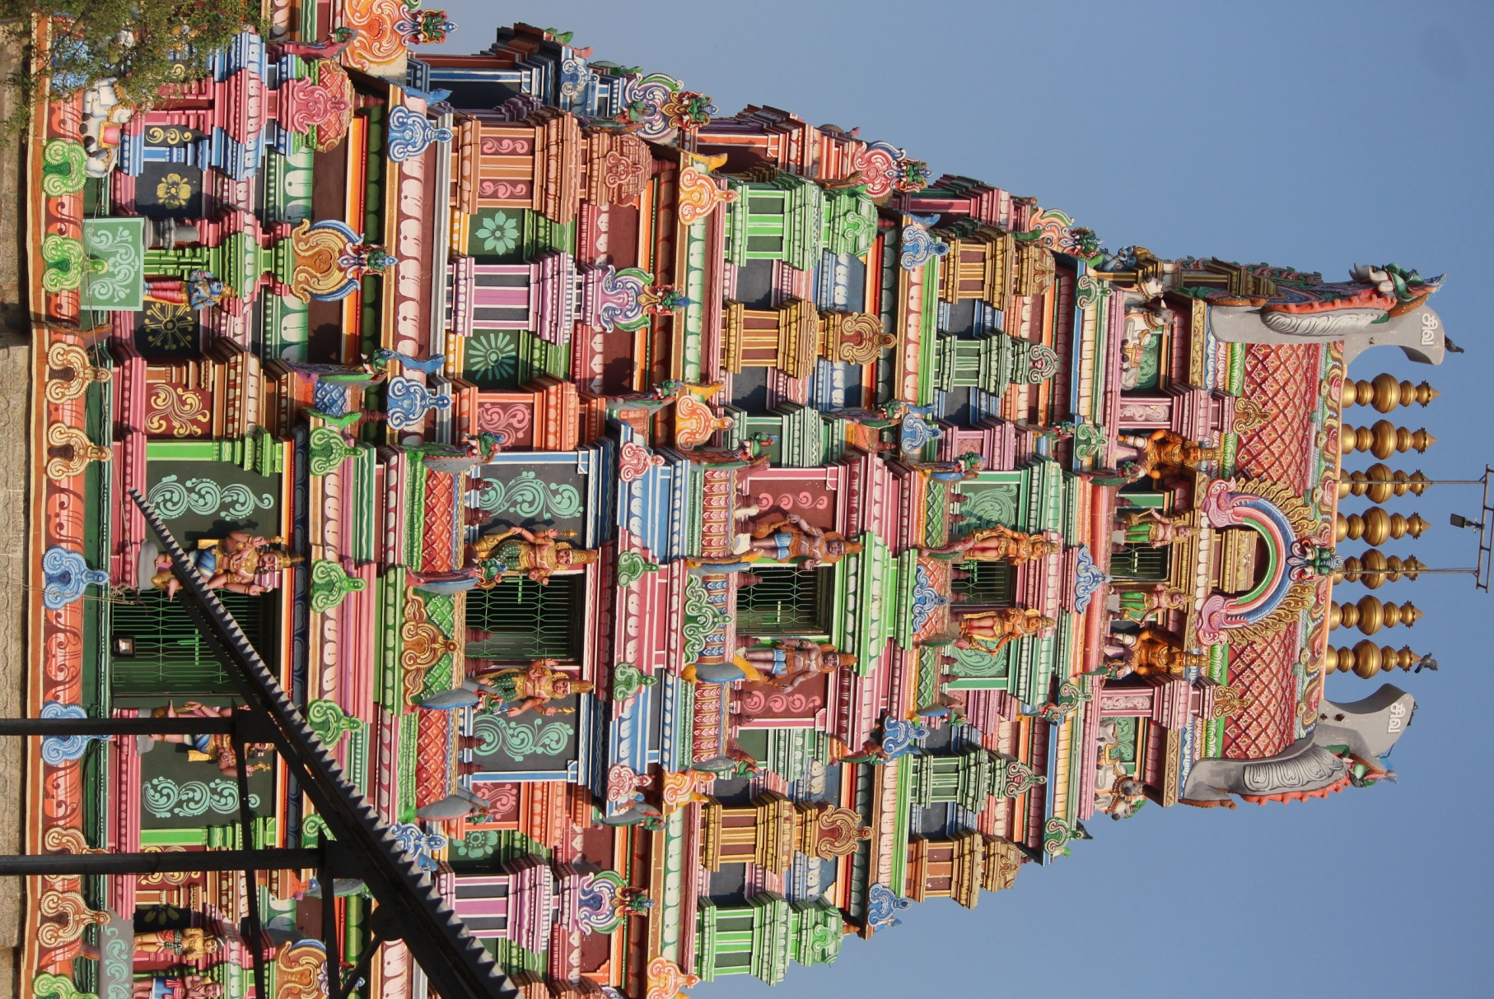Thirumalpur is a typical village in Tamil Nadu which was considered as part of Kancheepuram in the history of puranas.  Here there is a temple called ‘Shree Manigandeshwarar temple’, which was built about in 1600 B.C.  The Mythology Says that Lord Vishnu wanted to have Sudharsan Chakra from Lord Shiva, so Lord Vishnu performed pooja daily, with 1008 Lotus flowers.  One day while Lord Vishnu was performing pooja with 1008 Lotus, Lord Shiva had concealed one lotus flower from 1008 Lotus flowers so as to test the dedication of Lord Vishnu.  Lord Vishnu found that one Lotus flower was missing from 1008 Lotus, immediately Lord Vishnu offered one of his eyes as 1008th flower and kept at the feet of the Lord Shiva and performed the pooja.  Lord Shiva was very much pleased and blessed Lord Vishnu with required prayer and also declared the place in the name of Lord Vishnu i.e. Thirumal. Since Lord Vishnu got blessing (Peru) the place is called ‘Thirumarperu’ and in due course of time it is being called ‘THIRUMALPUR’.

Fig 1: Shree Manigandeshwarar temple ; source:self

2.2 GEOGRAPHICAL LOCATION OF THIRUMALPUR:

Thirumalpur is located in the North West border of Vellore district i.e. in between Kancheepuram and Arakkonam (20 kms away from Kancheepuram, 20 kms away from Arakkonam).  Thirumalpur is covered by Pallur in East, Panapakkam in West, Nemili in North and Vathiyur in South.  It is well connected by road from Kancheepuram, Arakkonam and Vathiyur and also connected by rail from Arakkonam and Kancheepuram.

Nearest Government Hospital          - Kancheepuram

District head quarter                        - Vellore

Nearest Railway junction                - Arakkonam

1. **ANALYSIS OF THE MACRO ENVIRONMENT:**

1. POLITICAL FACTORS:

DEMONETISATION: For the first time in Thirumalpur, few weavers collected their wages from the bank. Till earlier they would receive advance wages in cash from the cooperative materials along with materials for every sari they weaved. However, after the government announced that Rs 500 and Rs 1000 notes were no longer legal tender from November 9, their wages for weaving saris were transferred directly to their bank account. The weavers have hardly any savings anyway, so they didn’t have many notes to exchange. They just needed to withdraw the advance they got, used it to eat and then start to work.

While this was the first time that the weavers received their wages in bank accounts, they were not entirely unfamiliar with banks. They received their yearly bonus in the accounts. They also get loans from government schemes to buy certain weaving equipment parts. But while the production of sarees may not have been significantly impacted by the demonetisation, there was a definite downward spike in sales.

### DROP IN SALES**:** 70% of the sales of sarees take place in cash. Many people come with cash that they have saved up for an occasion and buy in bulk. But during the time of demonetization they were hesitant. January being the wedding season their sales during November and December are usually at their peak but because of notes ban they were terribly impacted.

### IMPACT ON PRIVATE BUSINESSES: The weavers said that they had also not been able to obtain the raw materials – zari from Surat, because of the cash crunch.

One of the weavers told, “Right from my grandfather’s time, my family has supported the Congress, so have I. But if somebody does something good, we have to acknowledge that. There was a lot of corruption during the Congress’s rule. They only took care of themselves. But Modi is not driven by family politics, he has the nation’s interest at heart.”

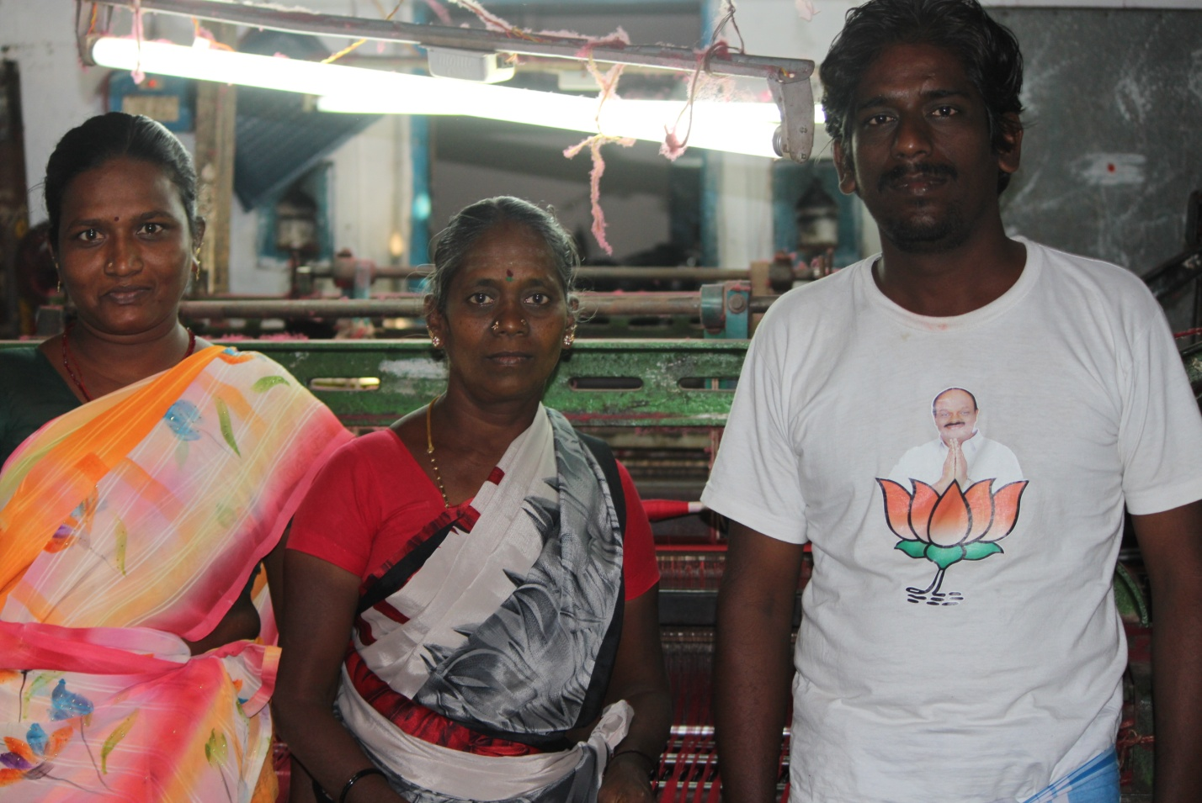

Fig 2: Villagers wearing shirts provided by party workers during elections ; Source: self

Most of the people are not under the cooperative society in Thirumalpur. They run their looms as private business and sell their sarees to dealers in Kancheepuram. This is also one reason as to why the weavers rarely interact with the consumer. Thirumalpur comes under village panchayat. There is no specific opening and closing time or holidays for these weavers, they work from the morning till its dark and even on weekends and public holidays. During election campaigning the Party symbols are painted on house walls. The party workers offer the house owners about 100 rupees to let them paint on their house walls. The villagers let them paint for the money they get in return but this doesn’t affect the vote they’d cast in any way.

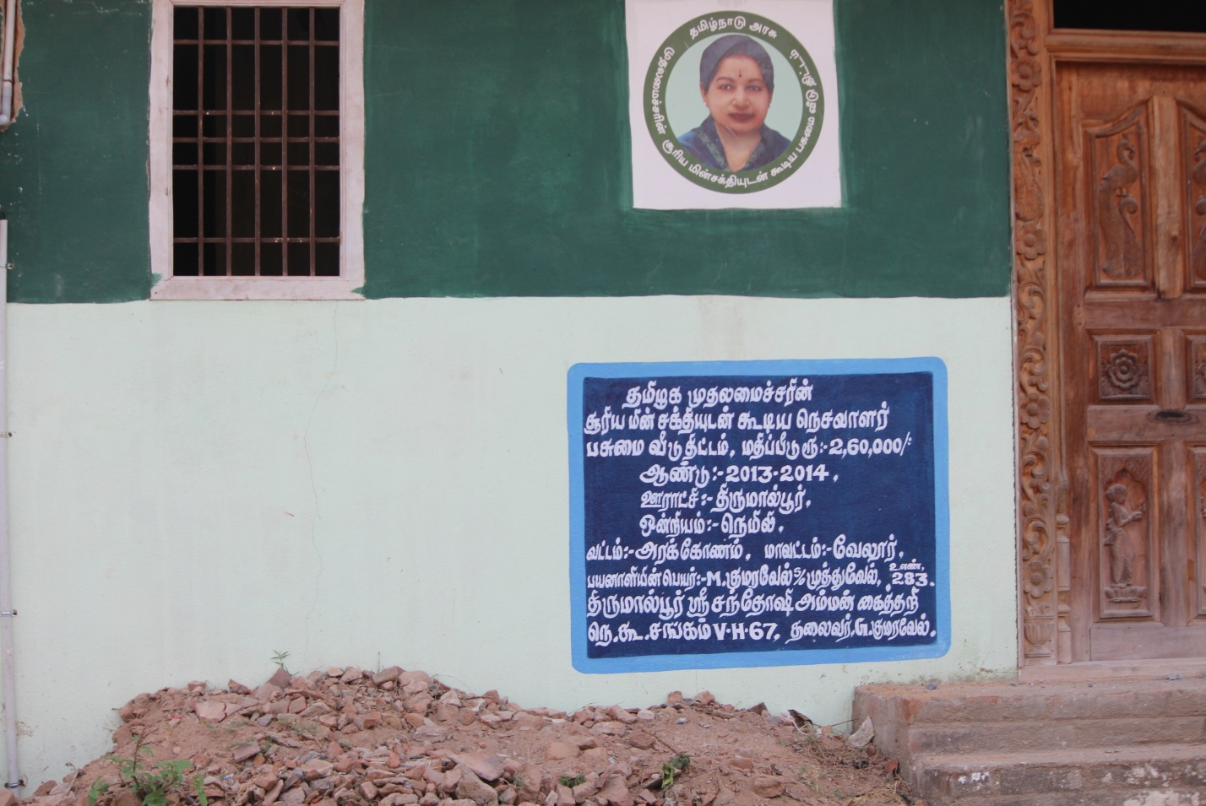

Fig 3: House built by the government for the villagers ; source:self

1. ECONOMIC FACTORS:

Economic disparity was clearly visible as some houses in the village were well built but on the other hand some were not in a proper condition. The reason behind such differences was that people chose different career options than weaving. The monthly income of the families is Rs. 1000.

Children suffer a lot due to the lack of facilities in the education. There is one government school in the area, it is a higher secondary school. The annual fees are Rs. 400 per student.The school had proper infrastructure but lacked on the number of teachers.

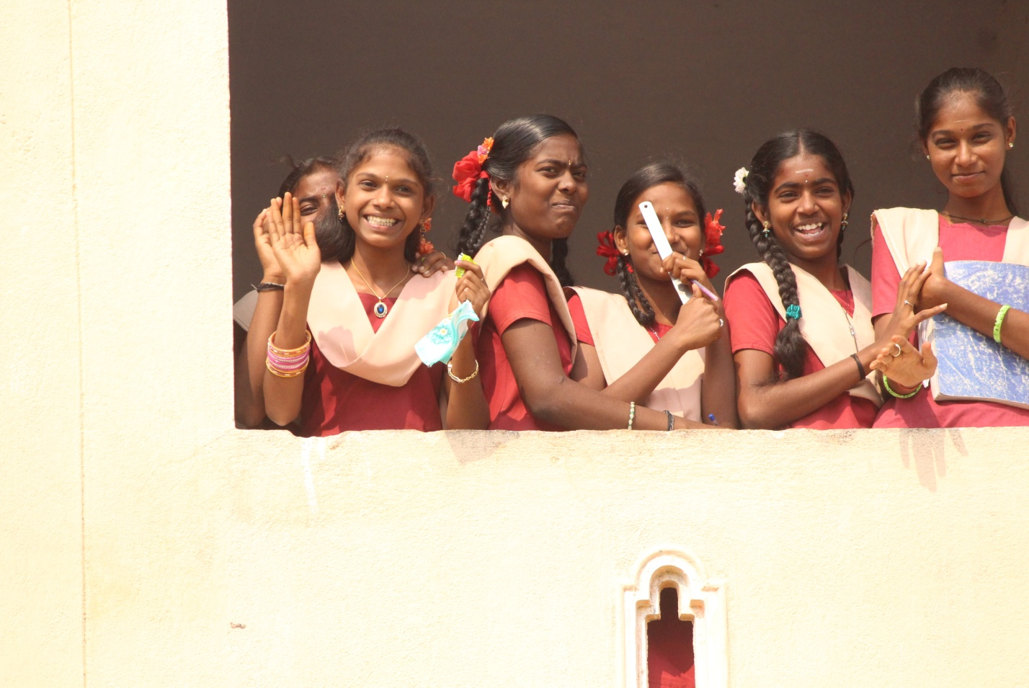

Fig 4: Children at the government school; source:self

Weaving one sari usually takes about 15 days, even more if it involves an elaborate design. Weavers get anywhere between Rs 1,000 to Rs 5,000 for his labour on a sari, which is often sold at double or triple the price in the market. This explains why the economic conditions of weavers in Thirumalpur are very poor.

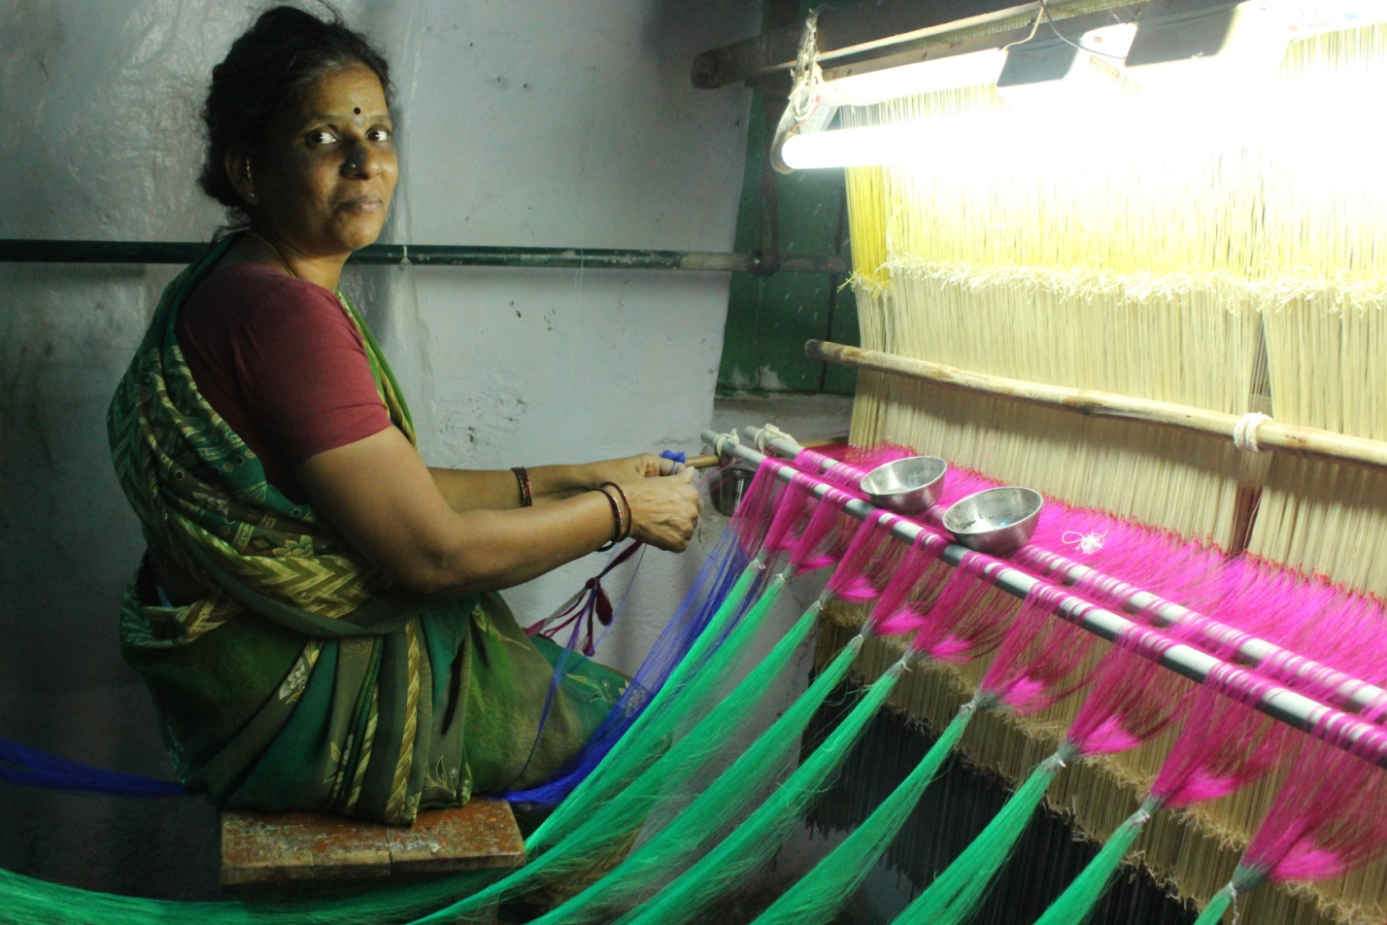

Fig 5: A woman tying yarns together, a very time taking process; source:self

Most of the weaving members involved in silk weaving are illiterates. As they are uneducated, they face many problems in knowing the modern techniques in weaving, in utilizing the welfare schemes of the Government, in getting financial assistance from banks and other similar funding agencies. There is hardly any unemployed person in Thirumalpur. Almost all of them weave sarees in the comfort of their homes along with their family. There is a bank (Canara bank) and India ATM in the villageThe cost of raw material has increased in the past few years and hence their earning has decreased.

Most of the parents send their children out of the village to work at a private company. Most of them have done engineering and work at VolTech in Bangalore. This is improving their economic condition as their children are able to earn much more than they could if they joined the ancestral weaving business. 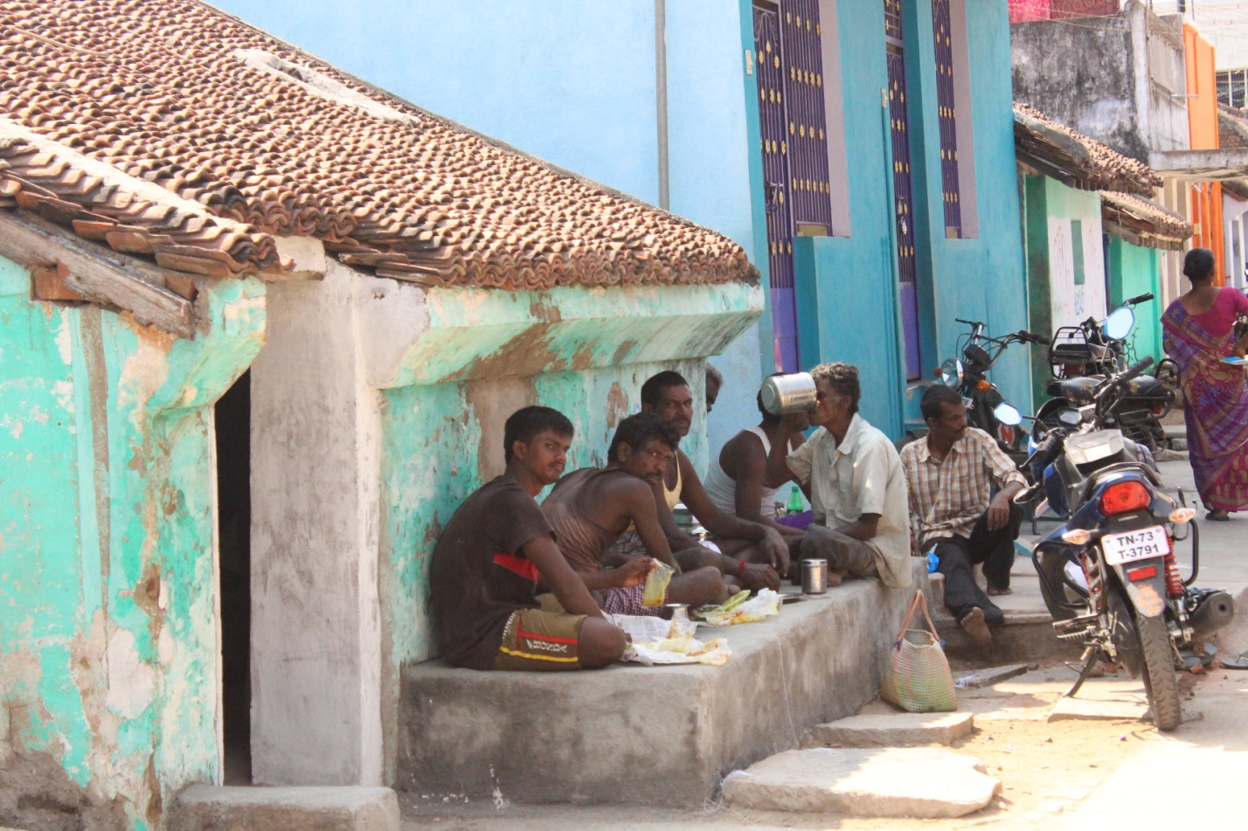

Fig 6: People sitting on the thinnai and eating together while they socialize ; source:self

1. SOCIAL FACTORS:

Thirumalpur is a census town place in district of Vellore, Tamil Nadu. The Thirumalpur census town has population of 4,803 of which 2,429 are males while 2,374 are females as per the report released by the census India 2011

| Town | Population | Hindu | Muslim | Christian | Sikh | Buddhist | Jain | Others | Not Stated |
| --- | --- | --- | --- | --- | --- | --- | --- | --- | --- |
| Thirumalpur | 4,803 | 99.33% | 0.06% | 0.60% | 0.00% | 0.00% | 0.00% | 0.00% | 0.00% |

(Thirumalpur religion data 2011, Table 1; Source: internet)

Population of children with age 0-6 is 483 which is 10.06% of the total population. In Thirumalpur census town, female sex ratio is 977 against the state average of 996. Moreover, child sex ratio in Thirumalpur is 902 compared to Tamil Nadu state average of 943 literacy rate of the place is 78.17% lower than the state average of 80.09%. in Thirumalpur, male literacy is around 87.68% while female literacy rate is 68.53%.

Thirumalpur census says that the town has total administration over 1,159 houses to which it supplies basic amenities like water. It also authorizes to build roads with census town limits and impose taxes on properties coming under its jurisdiction.

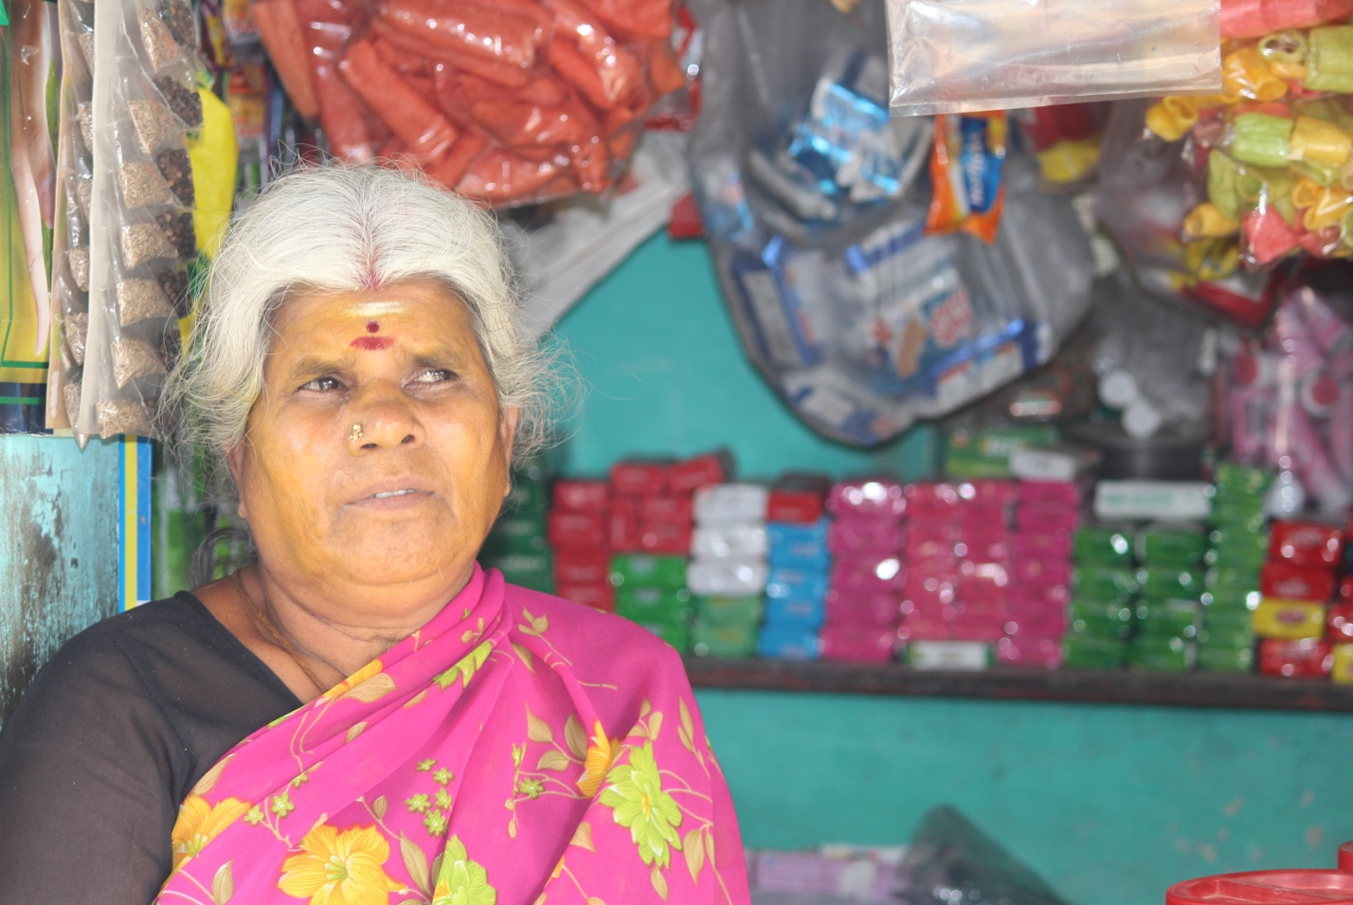

Fig 7: A shop owner ; source self

Almost every house in Thirumalpur has a loom either a power loom or a handloom some houses consist of as well. People mainly speak Tamil language in the place and they are not so connected to the outside world. We look at various other facilities in Thirumalpur-

Entertainment facilities:

* The nearest cinema theatre is 9kms away
* Almost all the houses had a TV
* The nearest hotel is Hotel Sri Annapurna Veg Restaurant which is 4.6kms away.

Medical Facilities:

* Medical facilities are not available in the village. People need to travel to Kancheepuram, Padapakkam or Attapakkam to visit a hospital.
* The village also lacks health centre, nursing homes and clinics. There are no private medical practitioners either.

Drinking water facilities:

* Drinking water facilities are available in the village. sources of water include, tap water, well water, tank water, tube water, hand pumps and other drinking water sources.

Telephone facilities:

* Every weaver has his or her own mobile phone.

Transport facilities:

* Though the village has bus services, which connects the village to nearby towns and villages, the frequency of the buses is less. This poses as a major problem to the residents of the village. Railway services are available from near the village.

Banking facilities:

* They have a Canara bank in the village itself. Indian bank ATM and Canara bank ATM are also available in the locality.

Lifestyle:

Men are seen wearing shirts and dhotis/trousers and women usually wear sarees. Agriculture and weaving of silk sarees are the main occupations of people here. Most of the population is involved in sari production, which is also the source of livelihood as they have been into weaving for generations and which is why the region excels in the production of silk sarees. Rich Dravidian culture was seen in the village. Majority of the population followed the Hindu religion and belonged to the Sengunthar caste and have been living there for generations. Rice is the staple diet. Sengunthar or Kaikkolar is a Tamil community found in the Indian state of Tamil Nadu. The word Kaikkolar comes from the words kai (hand) and kol (shuttle used in looms), Kaikkolar also means men with stronger arms. Sengunthar priests are vegetarian, wear the sacred thread, and shave their foreheads in the Brahmanic fashion. But when they are concerned with the sacred locus of the interior, meat eating, blood sacrifice, spirit possession, and the worship of small gods are all prominent. Sengunthar thus follow both a priestly model and a Dravidian tradition.

The farmers are able to earn depending on the area of land they have, but they rarely incur a loss because even during bad harvests they get back the cost of raw material atleast.

Traditional houses:

Each house had a wide verandah out front or one that ran around the house called a thinnai where you could relax or socialise away from the heat of the day. Pillars supported the terracotta roof of the thinnai. Other families used the more modest thatch roof. The most extravagant piece in any of these houses, which is a feature that survives to this day, is the front door, which is always intricately carved. There were beautiful kolams outside the house too.

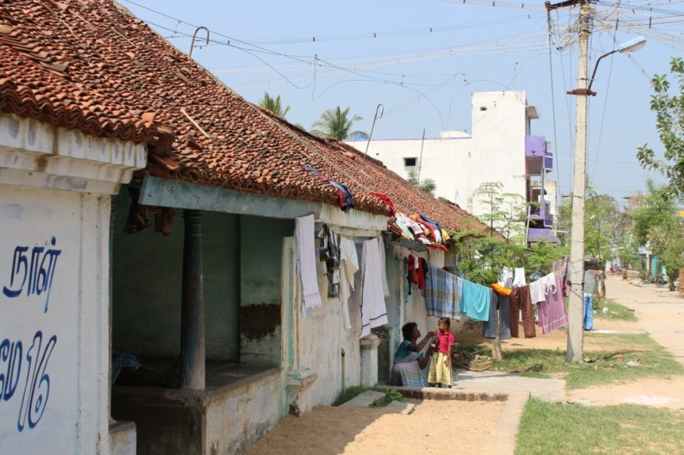

*Fig.8: (Thinnai in a traditional house ; source: self)*

*Fig.19 (Thinnai in a traditional house ; source: self)*

1. TECHNOLOGICAL FACTORS:

Research is being carried out in all spheres of mechanism to reduce the human drudgery by modernizing the mechanism and adopting the new technology time to time. In weaving industry, the technological modernisation has started from loin loom - throw shuttle weaving, to shuttle less weaving technology. In fact, throw shuttle weaving loom is the true handloom. The modernisation of the handloom had started, the day when the invention of fly shuttle started. During the past two decades, in many silk hand loom clusters, the pit looms used for silk saree weaving have been modernized with many technical developments by dispensing the old techniques used in preparatory, jacquard weaving and designing processes. The main objective of the modernisation of hand loom weaving and its related processes, ultimately, is to increase the earnings of the weaver, which is achieved by deriving two advantages namely 1) value addition to the products and 2) increasing the productivity.

Strength of the handlooms stays with weaving intricate silk sarees having more weft way intricacy for which highest skill of the weavers and complete modernisation of hand looms with multiple jacquard are required.

|  |  |  |  |
| --- | --- | --- | --- |
| S.No. | Old Machine And Mechanism Being Dispensed | Modernized Machines And Mechanism Being Used | Advantage |
| 1. | Single Jacquard with minimum hooks capacity (120 hooks) | Multiple jacquard with increased hook capacity (240, 480 hooks | Increased productivity & Value Addition |
| 2. | Jacquard operated by lifting lever and treadle | Jacquard operated by motor operated cam and pedal | Increased productivity |

(Technological advancements in looms, *Table 2; Source: self)*

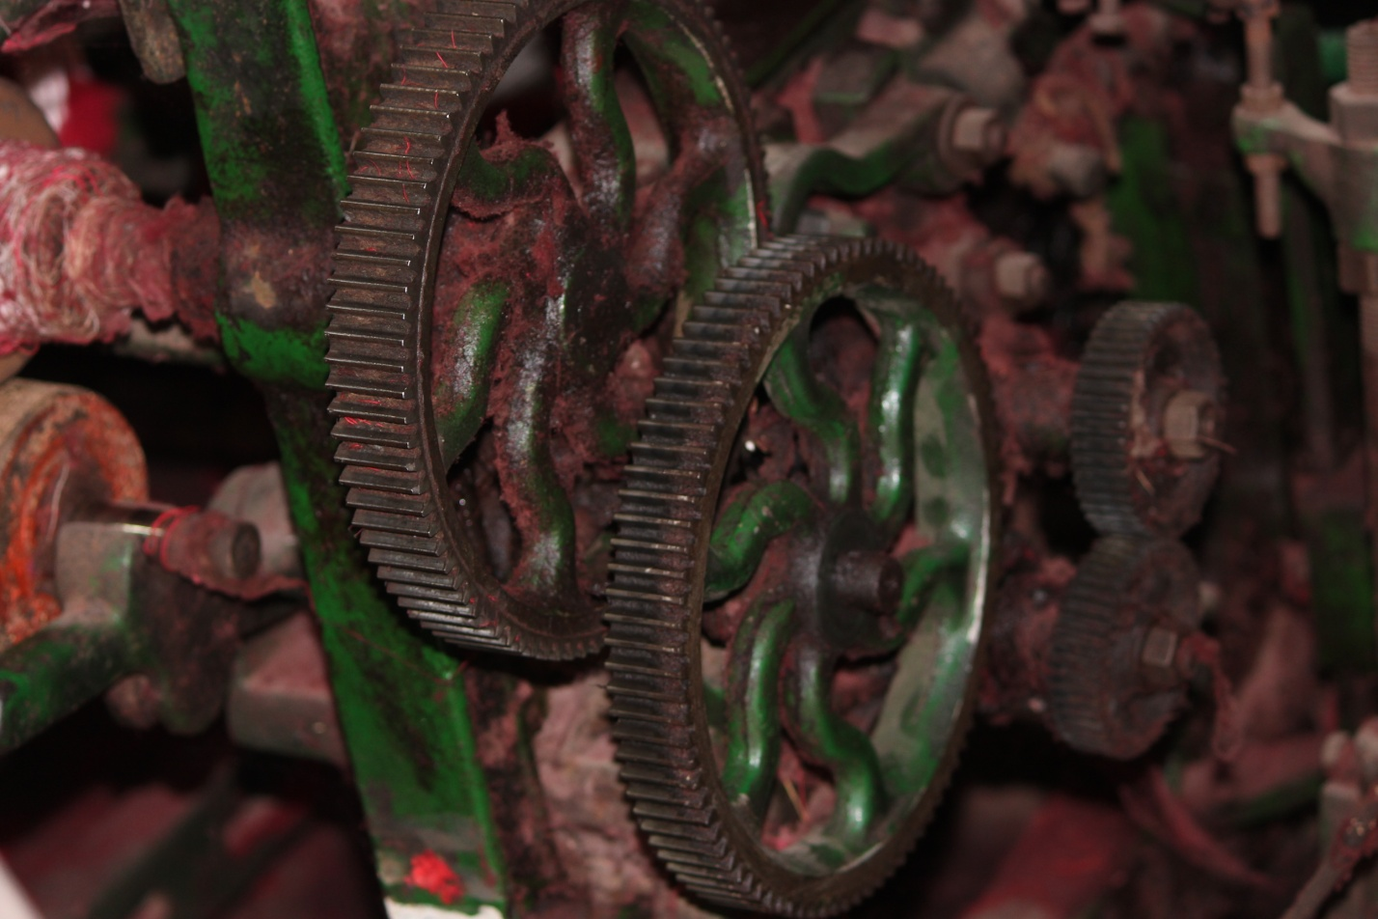

Fig 9: The gears of a powerloom; source : self

The houses which the government has built for the villagers incorporate solar panels but these solar panels are not yet working and hence these houses are still running on electricity.

Flipkart, Amazon and most of the other e-commerce websites delivery to Thirumalpur and the people in Thirumalpur order products online pretty frequently because of lack of retail stores and this clearly shows technology has come a long way even in the villages.

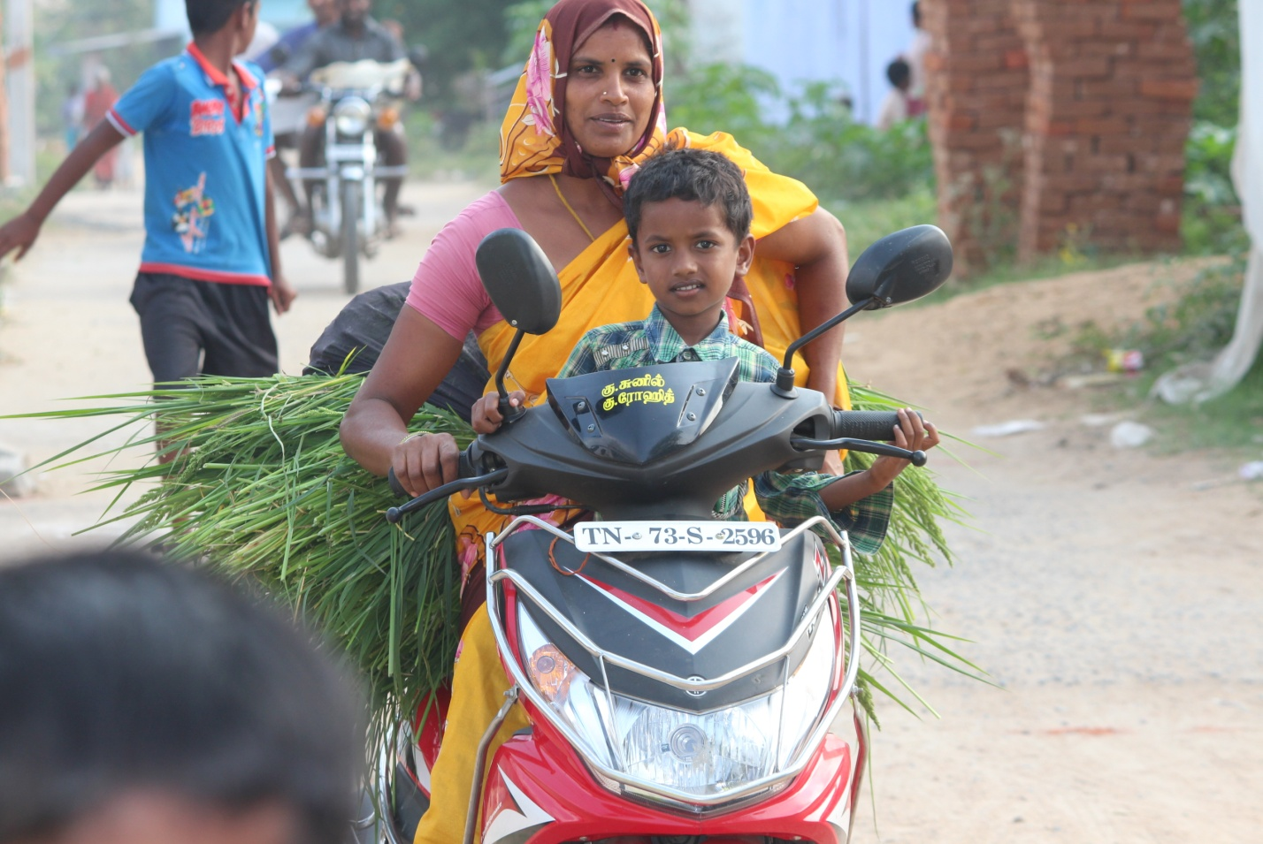

Fig 10: A lady driving her scooty with her son ; source : self

1. LEGAL FACTORS:

In 2005, the Government of Tamil Nadu applied for Geographical Indication for Kanchipuram sarees. The Government of India recognized it as a Geographical indication officially since the year 2005-06.

People of Thirumalpur say that there are no important legal issues filed in the village.

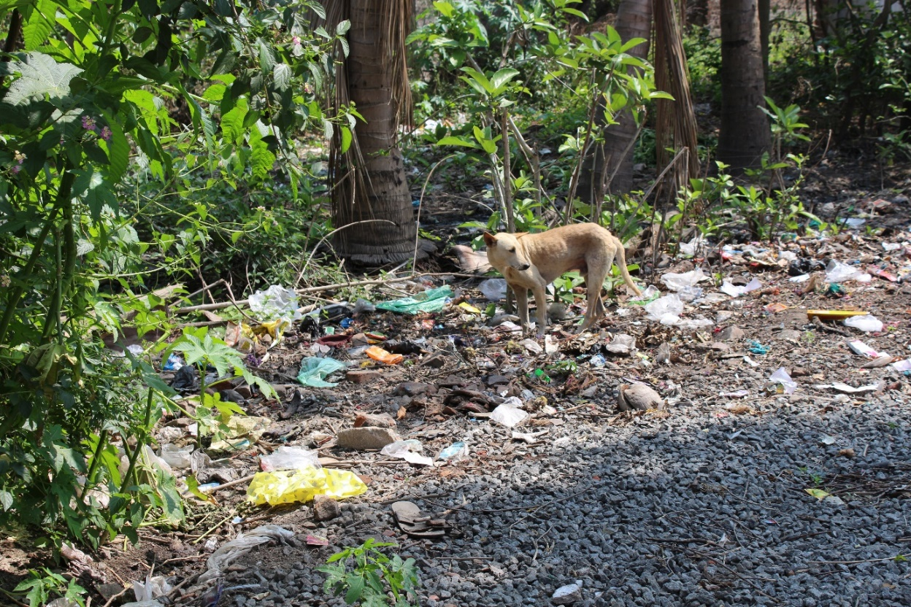

1. ENVIRONMENTAL FACTORS:

Thirumalpur is mostly hot and humid and during rainy season the place receives decent rainfall. Apart from weaving, people in Thirumalpur practice pottery and people who have their own lands also do farming and their main crop is paddy. The village receives south west and north east monsoon. The weavers face a problem during weaving during monsoon because the humidity increases which inturn affects the tensile strength of silk yarn whereas in summer there are no such problems faced. Heavy rains during monsoon result in power cuts. During the cyclone Vardha there was a powercut for 3 days.

Fig 11: Waste dumped near the trees ; source : self

1. **PRODUCTS PRODUCED**

**PRODUCTS MADE AT TIRUMALPUR**

|  |  |
| --- | --- |
| *PROPERTY* | *DESCRIPTION* |
| WARP | COTTON |
| WEFT | POLYESTER |
| LENGTH | 5.5m |
| WIDTH | 1.14m |
| MARKET PRICE PER PRODUCT | Rs. 160 |

1. Cotton Polyester Saree:

Janthar saree is a blend of cotton and polyester. Cotton is used in warp and polyester is used in weft. It does not have designs and motifs except lines along the border and pallu. Various colors are used such as pink, blue, green and yellow. The texture of the saree is soft. The saree is given to the people of Tamil Nadu during the Pongal festival by the government under the “Priceless Saree and Dhoti distribution Scheme”. It is established to benefit the poor and providing higher employment opportunities in the handloom, power loom sector.

|  |  |
| --- | --- |
|  | DESCRIPTION |
| WARP | SILK |
| WEFT | SILK |
| ZARI | USED FOR MOTIFS, BORDER AND PAL  LU |
| LENGTH | 5.5m + 0.5m( FABRIC FOR BLOUSE) |
| WIDTH | 1.14m |
| MARKET RATE PER PRODUCT | VARIES WITH THE PRODUCT Rs. 5000 – Rs. 50,000 |

1. Silk Saree:

Silk saris are woven in handlooms. They are woven with silk yarns and zari. The The patterns and motifs vary with each saree. Bright colors are used. The pallu and border are decorative. The surface of the saree is smooth and shiny.

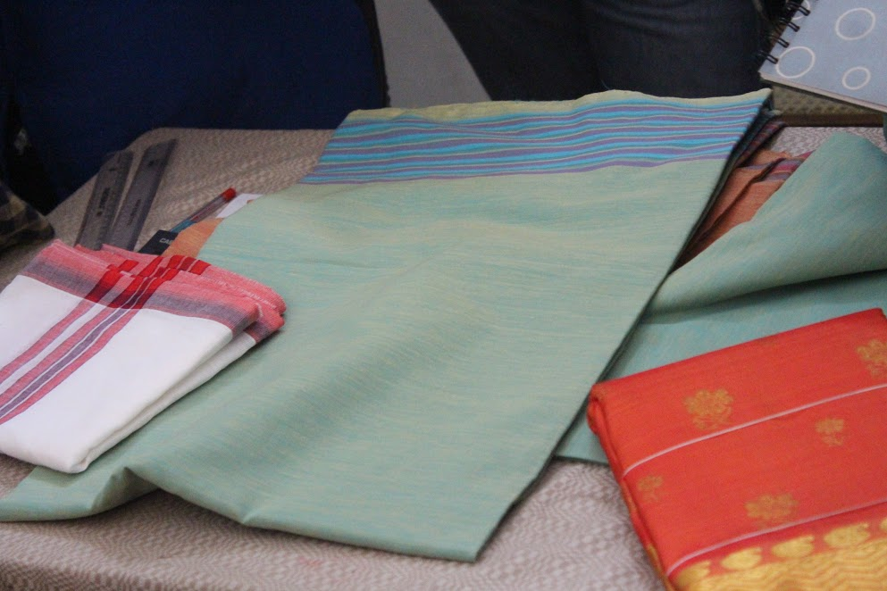

Fig 12: Pillaiyar Towel ( left ), Janthar saree ( middle ) and Silk Saree ( right ); Source : Self

|  |  |
| --- | --- |
| *PROPERTY* | *DESCRIPTION* |
| WARP | COTTON |
| WEFT | COTTON |
| LENGTH | VARIES WITH THE PRODUCT  20 – 40 inches |
| WIDTH | VARIES WITH THE PRODUCT  18 – 20 inches |
| MARKET RATE PER PRODUCT | Rs. 15 – Rs. 20 |

1. Pillayar Towel

Pillayar towels are used to drape the shrines in the temple. They are made in handlooms or power looms. They are mostly white in color with lines at the borders. They are made from cotton and the density of the fabric is less.

They are produced in various dimensions such as 20x 20 to 40x 20.

1. Lungi

|  |  |
| --- | --- |
| *PROPERTY* | *DESCRIPTION* |
| WARP | COTTON |
| WEFT | COTTON |
| LENGTH | 2m |
| WIDTH | 1.15m |
| DESIGN | MADRAS CHECKS |
| MARKET RATE PER PRODUCT | Rs. 250 – Rs. 400 |

Lungies are fabrics similar to dhoti that has to be draped around the waist. But they are stitched tubular for comfort. “Madras Checks are used on the lungies to create various checked patterns. Cotton is used in both warp and weft. The texture is soft.They are made from either handlooms or power looms.

1. **TYPE OF WEAVERS:**

**Independent Weavers:** These have their own looms and work by themselves. They are free to sell their goods as they please. More often than not they have verbal contracts with saree merchants in big towns to weave for them.

**Kuuli Weavers:** People who work on their looms for a wage. These could be from a traditional weaving caste or from other groups who have learnt the skill.

**Shed Workers:** Similar to Kuuli workers. Weavers who work in a shed on looms owned by a master weaver for a wage.

**Big men**: These are weavers or other entrepreneurs who have succeeded in acquiring a saree business big enough to command a number of looms, both their own and contracted looms. The common terminology for them is “master weaver” .

**Co-operative society members**- with the development of co operative societies in some towns, weavers could belong to one of them and supply sarees to be sold through them.

1. **COOPERATIVE SOCIETY:**

A co-operative society is a voluntary association started with the aim of service of its members. It is a form of business where individuals belonging to the same class join their hands for the promotion of their common goals. These are generally formed by the poor people or weaker section people in the society. It reflects the desire of the poor people to stand on their own legs or own merit.

In Tirumalpur 65 weavers are a part of the Sri Santoshi Amman Cotton and Silk Handloom Weavers Co-operative Production and Sales Society Limited which was started 15 years ago. To join this cooperative society a weaver has to make a one time payment of Rs. 110 and also they must have a handloom or peddle loom.

Sri Santhoshi Amman Cotton and Silk Handloom Weaver's Cooperative Production And Sales Society Ltd is associated with Co-Optex.

 The Tamil Nadu Handloom Weavers' Cooperative Society, popularly known as Co-optex, is a cooperative of traditional handloom weavers of the Indian state of Tamil Nadu. This is under the control of Department of Handlooms, Handicrafts, Textiles and Khadi (Tamil Nadu) of Government of Tamil Nadu. The organisation owns a number of shopping outlets in Tamil Nadu and also has an international arm.

The co-operative society provides the weavers orders for sarees along with raw materials and buys the sarees from them. The only problem being the sale of sarees is less from January to May and hence the weavers are given lesser orders as there isn’t enough storage.

The weavers who are a part of the co-operative society also get loans at subsidized rates. For example, if they take a loan of Rs.50,000 they have to return only 38,000 at 9% interest. They have a subsidy of Rs. 10,000.

The members of the cooperative society were given 95 free jacquard machines and 238 accessories so that they can weave more complicated sarees and upgrade their machines to the latest technology which could help them earn more money.

In order to increase the skill of the weavers the co-operative society gave training which was open to all the people in Thirumalpur, not only the members of the co-operative society. The weavers attended a month long training program in which they were taught designing, dyeing and weaving in 4 batches each of 20 weavers.

The members were also taken on a tour to Salem to give them exposure to other successful Handloom Cluster for trust building and capacity building in the minds of the weavers.

The cooperative society has also tried to do something different for the weavers by making them weave dupattas apart from the traditional products.

It is a fact that the more complex the Kancheepuram saree is the more costly it’ll be but at co-optex they sell sarees between the price range of Rs.3000 – Rs.4000 only. This is because they are able to provide the weavers with almost the same profit only even if they make costlier sarees because it takes more time to weave them.

Once a member has crossed the age of 60 he is given Rs.1000 per month and for the education of children members are given Rs.600 per year. 200 Watt of free electricity is given to each member.

The cooperative society gets a profit of 12% on each product which it uses to raise the living standards of weavers and buying raw materials.

1. **PROCESSING OF RECEIVING THE ORDER BY THE WEAVER:**

ORDER

ENTERING ON THE RECORD BOOK

SUPPLY:

YARN SPINDLES, ZARI, DESIGN SHEET AND PUNCH CARDS

TRAVEL BACK TO THIRUMALPUR

WEAVING

TRAVEL BACK TO THE PRIVATE ORGANIZATION WITH THE FINISHED PRODUCT

TRAVEL BACK TO THE PRIVATE ORGANIZATION WITH THE FINISHED PRODUCT

RETURN THE PRODUCT

RECEIVE WAGES

The orders for weavers are given only when the weavers reach out by themselves and request for orders. Weavers working under private organizations in Kanchipuram, travel to Kanchipuram for receiving orders.

Weavers are given a record book to maintain the track of orders and wages. Weavers must carry the record books while taking an order. Details of the raw materials, wastage percentage, date of placing the order and closing the order are entered on it.

Design is given in a sheet with printed patterns and motif and handwritten calculations for the alignment of warp and weft.

The weaver has to himself take the product and return it back to the private organization.

The travel expenditure, transporting raw materials and finished products are at the own risk of weaver.

Some of the private organizations include:

Senthil Silks, DCV Silks, Ravi Silks, N Raghu Silks and etc

These organizations order the products for their organization and showroom or sell it to larger organizations such as Pothys and Nalli Silks.

1. **TOOLS AND INFRASTRUCTURE USED IN WEAVING:**

|  |  |
| --- | --- |
| PROCESS | INFRASTRUCTURE AND TOOLS |
| RAW MATERIAL | Yarns, Zari |
| WARPING | Sectional warping machine, spindles |
| SIZING | Starch paste |
| WEAVING LOOM | Handloom, power loom |
| PURN WINDING | Purn, spindles, winding wheel, bamboo spools |
| WEAVING | Shuttle, punch cards |

(Tools and infrastructure, *Table 3; Source: own*)

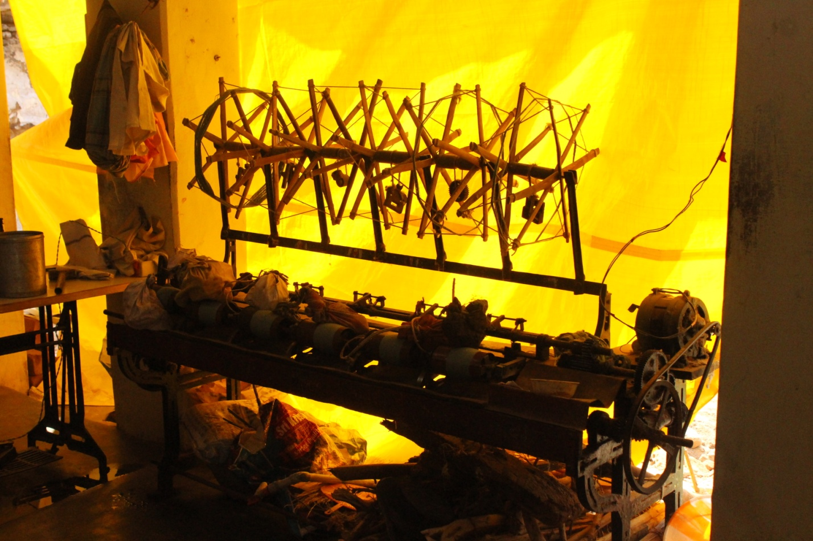

Fig 13: Machine used for preparing the warp beam ; source: self

COTTON YARNS:

It is a soft, fluffy staple fiber that grows in a boll, or protective case, around the seeds of the cotton plants of the genus *Gossypium* in the mallow family *Malvaceae*. The fiber is almost pure cellulose. The fiber is most often spun into yarn or thread and used to make a soft, breathable textile.

It has good strength in both wet and in dry conditions. It has perfect dimension stability. It has better moisture absorbency and thus is mostly used for making sportswear, athletic wear, yoga wear, etc. Other properties are comfortable, soft, good absorbency, colour retention, Machine-washable and Dry-cleanable, good strength and the ability to Drape well.

POLYESTER YARNS:

Polyester fibers are long chain polymers containing esters. It is formed by the process of condensation. They are extremely strong fibers. It is durable and is resistant to most chemicals, stretching and shrinking, wrinkle resistant and abrasion. It is easily washed and dried.

SILK YARNS:

Silk is a natural protein fiber, some forms of which can be woven into textiles. The protein fiber of silk is composed mainly of fibroin and is produced by certain insect larvae to form cocoons. The best-known silk is obtained from the cocoons of the larvae of the mulberry silkworm *Bombyxmori* reared in captivity (sericulture).

It is a lustrous and strong filament yarn.

ZARI:

Zari (or Jari) is an even thread traditionally made of fine gold or silver used in traditional Bengali, Indian, and Pakistani garments, especially as brocade in saris etc. This thread is woven into fabrics, primarily made of silk to create intricate patterns. Zari is basically a brocade of tinsel thread. It is manufactured by winding or wrapping (covering) a flattened metallic strip made from pure gold, silver or metallised polyester film, on a core yarn, usually of pure silk, viscose, cotton, nylon, polyester, wire, etc.

In ancient times, when precious metals were cheaply and easily available, only real zari threads were produced. Due to industrial revolution and invention of electroplating process, imitation techniques came into existence to cut the cost of precious metals. As copper is the most malleable and ductile metal after gold and silver, silver electroplated copper wire replaced pure silver. Various modern colours and chemicals are used to create/impart a golden hue instead of pure gold.

The precious metals and copper too became dearer due to huge demand in various modern industries. Thus, a cheap and durable alternative was invented with non-tarnishing properties. [Metallic zari](https://en.wikipedia.org/w/index.php?title=Metallic_zari&action=edit&redlink=1) came into vogue replacing traditional metals like gold, silver & copper. This non-genuine modern zari is light in weight & more durable than earlier editions.

Also, it has the sought after properties of resistance to tarnishing and knotting

**RICE STARCH:**  
Starch is extracted by boiling rice. The ladies of the house hold keep extracting the excess water used for cooking rice. The starch gets accumulated in the solution. When the solution starts to smell sour it is ready for use. The extracted solution is locally called as Kanji. Yarn is dipped in the kanji to obtain stiffness.

**SPINNING WHEEL:**  
This is a hand cranking spinning wheel which is locally called as ‘Mara Ratinam’. This is done on a home grown reeling system, often using a bicycle wheel. The bobbins were at one time made of DarbaKutchi- the thick stem of the darba grass. Today they have been replaced by plastic bobbins. These spindles are used in weaving process for weft weaving.

**FLY-SHUTTLE:**  
It is mainly used to process the weft. The spools are inserted in fly-shuttle while weaving. These shuttles are made of whole bamboo pole.

**WARP BEAM:**  
The length of yarn is wound on warp beam which is later loaded into the loom. When the warp yarn is mounted on the loom it is tied to a cloth beam (called padamaram) at one end of the loom and then stretched across to the other end to another beam, the oothukattai. The distance between the two beams is usually 12 feet

**JACQUARD MACHINE:**  
The loom is controlled by a "chain of cards", a number of punched cards, laced together into a continuous sequence. Multiple rows of holes is punched on each card, with one complete card corresponding to one row of the design. Each position in the card corresponds to a "Bolus" hook, which can either be raised or stopped dependent on whether the hole is punched out of the card or the card is solid. The hook raises or lowers the harness, which carries and guides the [warp](https://en.wikipedia.org/wiki/Warp_(weaving)) thread so that the [weft](https://en.wikipedia.org/wiki/Weft) will either lie above or below it. The sequence of raised and lowered threads is what creates the pattern. Each hook can be connected to a number of threads, allowing more than one repeat of a pattern.

**HANDLOOM:**  
A handloom, is any loom that is manually operated, unlike motorized or electrically powered looms. It is an apparatus on which weavers create fabric by interlacing the warp and weft threads. By providing tension on the warp threads, a hand loom enables the weaver to create cloth quicker and results in a more even weave. There are numerous types of hand looms, from simple, portable backstrap looms to complicated, room-sized jacquard looms.

**PUNCH CARDS:**  
The design is punched on the punch cards. The cards are loaded into jacquard machine.

**PARIVATTAM:**  
Bamboo spool used to wind the yarn to form silk bundles.

1. WEAVING PROCESS:

Weaving is a method of textile production in which two distinct sets of yarns or threads are interlaced at right angles to form a fabric or cloth. Other methods are knitting, felting, and braiding or plaiting. The longitudinal threads are called the warp and the lateral threads are the weft or filling. Cloth is usually woven on a loom, a device that holds the warp threads in place while filling threads are woven through them.

The way the warp and filling threads interlace with each other is called the weave. The majority of woven products are created with one of three basic weaves: plain weave, satin weave, or twill. Woven cloth can be plain (in one colour or a simple pattern), or can be woven in decorative or artistic design.

PROCESS:

warping

WARPING

SETTING UP THE LOOM

SIZING

PIRN WINDING

WEAVING

WARPING:

Yarns for warping are stretched out from the bundles or spindles and are given for warping. Warping is aimed at preparing the weaver’s beam to be set up on the weaving machine.

The creel is a stand for holding the supply packages in the form of a wound packages. It enables to hold the supply packages in proper position for warping.

Sectional warping is done. Sections of the Warp ends are first wound onto a drum tapered with a given cone angle. Then the warp threads altogether are transferred onto a weaver’s beam by unwinding the drum.

It takes 3 hours time to prepare 1 warp beam with sectional warping machine that runs with electricity

SETTING UP THE LOOM

The loom is set up after the warping process. The warp beam is fixed. Then the warp yarns are drawn across the loom. The heddle shafts are connected to the yarns, based on design requirements. Punch cards are fixed and twines are drawn. The set up of the loom remains the same until the completion of weaving yarns in warp beam.

Weaver’s set the looms by themselves. The time required to set up the loom varies with complication of the design. Weaver’s invite labors to set up the loom when the design or the process of setting up a loom is complicated.

Setting up the loom is completely a manual and time consuming process.

The main parts of the loom are: Sley, Treadles, Reed, Healds, Warp Beam, Cloth beam, Shuttle and Lease rods.

SIZING:

Sizing is the application of adhesive coating in the warp threads before weaving. It is done to protect the yarn from abrasion and improve the breaking strength of the yarn. This process also decreases the hairiness and increases the smoothness of the fabric.

Weavers prepare the adhesive by themselves by mixing starch, Maida and wax. It is called as “gondhu”.

PIRN WINDING:

The pirn winding process involves the process of converting the yarns in spindle form to pirn. The pirn is filled by spinning wheel that is operated in hand. Then they are inserted in the shuttle and are used for the weft insertion.

The yarns winded on tin boxes are transferred to the spinning wheel. Then the pirn is winded by rotating the spinning wheel .Weavers also use pirn winding machine

Weft yarns and zari are pirn winded.

Bamboo spools are used for winding silk yarns.

WEAVING:

PRIMARY MOTION OF THE LOOM

Shedding: where the ends are separated by raising or lowering [heddles](https://en.wikipedia.org/wiki/Heddle) to form a clear space where the pick 6 can pass.

Picking where the weft or pick is propelled across the loom by a shuttle.

Beating up where the weft is pushed up against the fell of the cloth by the reed.

SECONDARY MOTION OF THE LOOM:

Let off motion:let off the warp beam at a regulated speed to make the filling even and of the required design. warp yarns are let-off.

Take up Motion: Takes up the woven fabric in a regulated manner so that the density of filling is maintained

1. **MOTIFS AND DESIGN:**

The motifs are drawn from the nature and forms of temple architecture like peacock, parrot, temple designs, scenes from Ramayana, Mahabharata, and Bhagwad Gita. Few of the best known patterns in Kanchipuram saris are Mayilkann (peacock eye), Kuyilkann (nightingale eye), Rudraksham (Rudraksha beads) and Gopuram (temples).

|  |  |  |  |  |
| --- | --- | --- | --- | --- |
| **S.NO** | **MOTIF** | **PICTURE** | **DESCRIPTION** | **DESIGN PICTURE** |
| **1** | **Parrot** | Image result for parrot motif | **It is a symbol of courtship and passion seen in Indian art mostly in company of Krishna and Radha, Hinduism’s eternal lovers.** | C:\Users\HI\Desktop\Fs pictures\IMG-20170415-WA0007.jpg |
| **2** | **Hansa or Goose** | Image result for hansa or goose motif | **The animal symbolism of the goose hasn't got its full honour. Too often in myth and lore we see the goose representing silly attitudes or lazy dispositions. On the contrary, the symbolism of the goose is quite inspiring.** | **C:\Users\HI\Desktop\tt.jpg** |
| **3** | **Peacock**/ **Annap- akshi** | **C:\Users\HI\Desktop\io.jpg** | **The Peacock motif is a symbol of immortality since according to ancient mythology it was believed that the Peacock's flesh did not decay after fatality. The Peacock motif has played an important role in defining cultures across several countries like India** | https://sareepevaaree.files.wordpress.com/2014/09/img_6314-640x427.jpg?w=800 |
| **4** | **Jasmine** | **C:\Users\HI\Desktop\ji.jpg** | **Jasmine is a popular flower associated with love and romance. Its showy white blooms and heavenly fragrance are ideal for moon gardens where lovers spend time whispering sweet nothings under the stars.** | **C:\Users\HI\Desktop\Fs pictures\IMG-20170415-WA0016.jpg** |
| **5** | **Mango** | C:\Users\HI\AppData\Local\Microsoft\Windows\Temporary Internet Files\Content.Word\download (25).jpg | **The ‘mangaai’ or mango motif is one of the most popular and enduring motifs in traditional Indian design. A fruit that has a firm place in Indian mythology (the young Lord Ganesha and his brother Lord Muruga having contested for it!), the mango has made its presence felt in the Kanjivaram weaving tradition too** | **C:\Users\HI\Desktop\Fs pictures\IMG-20170415-WA0011.jpg** |
| **6** | **Horse** | **C:\Users\HI\Desktop\Fs pictures\IMG-20170415-WA0012.jpg** | **Serving man in war, mobility, productivity, agriculture, development of all kinds, the Horse is by far one of the largest contributors to the enhancement of civilization** | C:\Users\HI\AppData\Local\Microsoft\Windows\Temporary Internet Files\Content.Word\images (33).jpg |
| **7** | **Sun**  **-flower** | **C:\Users\HI\Desktop\Fs pictures\IMG-20170415-WA0002.jpg** | **Sunflower in its various forms has been adorning Indian textiles, since a very-very long time. But these beautiful flowers have not been merely used for decorative purposes; they have hidden meanings behind them. Somewhere they depict the Cosmos and the beauty of a woman.** | C:\Users\HI\AppData\Local\Microsoft\Windows\Temporary Internet Files\Content.Word\images (34).jpg |
| **8** | **Leaf** | **C:\Users\HI\Desktop\Fs pictures\IMG-20170415-WA0004.jpg** | **This motif has been taken from mughal art and is mostly preferred motif as it fills in the area with free flow design.apart from that they look harmonious and rhythmic which gives the viewer a pleasent feeling .these motif are taken .** | C:\Users\HI\AppData\Local\Microsoft\Windows\Temporary Internet Files\Content.Word\images (35).jpg |

|  |  |  |  |  |
| --- | --- | --- | --- | --- |
| 9 | Voluptuous vines |  | In artistic traditions, the Tree of Life is often depicted as a sinuous, multi-branched vine laden heavily with fruit and flowers, often home to a variety of birds and animals, a symbol of limitless abundance, fertility and the cyclical pattern of life. | https://cdn.shopify.com/s/files/1/0460/1105/files/121_large.jpg?327280529077644251 |
| 10 | Padma |  | . It represents a fundamental principle of Hindu philosophy, that of maintaining purity and detachment through the vicissitudes of life. | https://cdn.shopify.com/s/files/1/0460/1105/files/075_grande.JPG?652 |
| 11 | Yali – the beautiful beast | C:\Users\DELVIYA\AppData\Local\Microsoft\Windows\INetCache\Content.Word\images.jpg | It represents ferocity, strength and guile. | C:\Users\DELVIYA\AppData\Local\Microsoft\Windows\INetCache\Content.Word\images (1).jpg |
| 12 | Sacred checks and mesmerizing tracks | Image result for thandavalam | . The check motif is a representation of a sacred grid that symbolizes the universe. The horizontally running lines are parallel to the earth while the vertical lines arise from earth and go upwards. The crossing and linking of these lines is thought to create the cosmic energy that is manifest in all of creation. | https://cdn.shopify.com/s/files/1/0460/1105/files/084_grande.jpeg?662 |

( Motifs, *Table 4; Source: own*)

1. **BORDER AND PALLU:**

The speciality of Kancheepuram silk saree is contrast border with Korvai technique and contrast pallu with Petni technique. Contrast border is woven using three shuttles, two shuttles for both side border and one shuttle for body of the saree. Contrast Pallu is woven using Petni technique.

The contrast borders and pallus are achieved by Petni and Korvai technique.

**Korvai**: is the technique of joining the border to body of the saree [Single/ double sided border]. This techniques requires additional manpower, which generally fulfilled by employing household labourer. Since this process requires additional labourer, who has to synchronize his activity of weft insertion with the experienced weaver, results in enormous delay.

**Petni:** process, which is nothing but mending the Pallu portion of warp with the existing portion of the body in each saree. This involves mending of all the warp threads in the body portion of the saree, which counts to few thousand.

The contrast yarn is laid over the body of the warp. The new contrast warp is held firmly and then the weaver weaves an inch or two, beating the weft firmly. After another inch or two of weaving and the weft beaten down firmly, the old warp is cut and the weaver continues weaving the contrast pallu.

1. **WASTE MANAGEMENT**

Punch cards are either returned back to the owner or stored by the weavers themselves. Some of these punch cards are re used. Some of the old punch cards are destroyed by burning or dumped in garbage.

Yarns are mostly not wasted as they are weighed in proper quantity and supplied. Even the zari is mostly not wasted.

Usually there will be no large amount of waste cloth pieces. The waste cloth pieces are usually burnt as they are so small in size because of which they can’t be used in the weaving process.

FAILED PRODUCTS

When enquired about the failed products, weavers said that usually those will be used by them and in some cases they design a new cloth from it.

Usually the failed products will not be in large amounts; sometimes some private companies do undertake such failed products, in order to create something new products out of it.

1. **COSTING OF THE PRODUCTS:**

RAW MATERIALS

Cost of pure silk is Rs. 4,250 per kg and of blended silk is Rs. 1,300 per kg.

The cost for dyeing is according to the weight of silk. For dyeing 1kg silk yarn the price is Rs.200.

Cost of brass zari for 1 saree is Rs.2000 (1 gram is 6 rupees)

Cost of gold zari for 3 sarees is Rs. 25,000 (one bobbin of gold zari).

Zari is sold in a measure called Marc, one marc being 242 grams of gold. Theoretically1

Marc of pure zari should contain 55% - 57% silver and 0.6% gold.

Cost of one punch card for a medium level design is Rs.6000

LABOUR WAGE

* UNDER GOVT.

The wages vary from Rs.150 – 250 per day. They usually work for 8 hours or more a day.

COTTON SAREE- The time taken to complete one saree is 3 ½ hours. They get a daily wage of Rs.140.

SILK SAREE - The time taken to complete a silk saree with a handloom is 7 days. They get a daily wage of Rs. 200.

LUNGI - The time taken to complete one lungi is hours. They get a daily wage of Rs. 480 for weaving 200 m of lungi.

UNDER PRIVATE

The wages vary from Rs.170 – 240 per day. They usually work for 8 hours or more a day.

If they are working under a head weaver then they are paid a daily wage of Rs. 140.

COTTON SAREE- The time taken to complete one saree is 3 ½ hours. They get a daily wage of Rs. 170.

SILK SAREE - The time taken to complete a silk saree with a handloom is 7 days. They get a daily wage of Rs. 180.

* UNDER SELF

For per meter of saree they are been paid Rs. 35-45.

COTTON SAREE- The time taken to complete one saree is 3 ½ hours. They get a daily wage of Rs 220.

SILK SAREE - The time taken to complete a silk saree with a handloom is 7 days. They get a daily wage of Rs. 300.

PILLAYAAR THUNDU – They get a daily wage of Rs. 150.

C. FINISHED PRODUCT COST

ORIGINAL SILK SAREE – Rs.30, 000 – 1, 00, 00 and more

DUPLICATE SILK SAREE – Rs. 8000.

COTTON SAREE – Rs. 250 – 1000.

1. **PROBLEM AND ISSUES:**

MAJOR PROBLEMS FACED BY PEOPLE IN THIRUMALPUR ARE:

•Financial problem

•Health problem

•Less scope of learning

•Education

•Less job opportunities

FINANCIAL PROBLEM:

Almost 99% of the population of Thirumalpur is involved in weaving industry. Most of them take orders from co-operative society and few of them are connected with private retailers in kancheepuram but the livelihood conditions are same in both the cases. They are not economically strong like middle men or retailers involved in this business because they are not directly connected to customer. They get only little profit after spending so much time and money. Many people told that they don’t have option other than to accept what cooperative or middle offer them because they can’t go directly and sell the products to customers.

They told that sometimes they have to takes loans from bank because of loss in previous. According to them, the cost of raw material are increasing day by day but they get the same profit as they use to get in previous years so they are going in loss. But from this year, they increased the price of their products.

HEALTH PROBLEMS:

Healthcare is the right of every individual but lack of quality infrastructure, scarcity of qualified medical functionaries, and non- access to basic medicines and medical facilities thwarts its reach to 60% of population in India. A majority of 700 million people lives in rural areas where the condition of medical facilities is inexcusable and its the same in Thirumalpur. People have no choice but to go to Kancheepuram for the smallest health issues.

Most of the weaver suffer from eyesight problem, back-pain problem, leg ache problem and other joint pain problems due continues hard work.

The village lack health facilities. They don’t have any private or government hospital though they have one government veterinary hospital.

EDUCATION:

Majority of India still lives in villages and so the topic of rural education in India is of utmost importance.

Quality and access to education is the major concern in rural schools as there are fewer committed teachers, lack of proper text books and learning material in the schools. Though Government schools exist, but when compared to private schools then quality is a major issue. Majority of people living in villages have understood the importance of education and know that it is the only way to get rid of poverty.  Thirumalpur has a government school, but  parents tend to send their children to private schools for better education which is quite expensive.

LESS SCOPE FOR LEARNING:

Weavers living in Thirumalpur have very less opportunity of learning. There is only one training institute where they can go and learn how to make new design and pattern.

Most of the people are not trained and can’t make new design which reduce their chances of sale and affect their economic condition. They only make few patterns which they learnt from their ancestors and the other weavers who got trained can make different patterns so their sales are higher than them.

With liberalization of Indian economy, the modern textile industry has posed serious threat to the traditional handloom industry. Rapid technological upgradation and automation in textile industry has made high volume of production of a variety of quality synthetic and cotton textile items, enjoying competitive advantage over the handloom products. The handloom industry, both in co-operative and private sector, with its vast rural work force especially of weaver communities is confronted with challenge of competitive economic environment. The weakening position of handloom sector in the wake of global competition of textile industry has posed a serious threat to the socio-economic life of the traditional weaver communities, in general and to the socio-economic status of silk weavers in particular.

JOB OPPURTUNITIES IN THIRUMALPUR:

Most people in Thirumalpur have weaving as their occupation and the rest practice agriculture, most of the youth work in different cities because of lack of job opportunities and also because weaving fetches very little profits for them.

PROBLEM IN WEAVING PROFESSION:

1. Rising input costs: The prices of yarn, dyes, chemicals and other inputs have increased sharply in the recent period. This has resulted into cost disadvantage to the weavers.  The problem is more acute for the individual weavers who need small quantities of yarn and chemicals. This situation is affecting the level of output in the handloom industry.
2. Lack of modernization:  The handloom industry has been using age old technology and looms. These results into low productivity and high cost. Again the continuous and repetitive movements of production process adversely affect the speed of production.
3. Migration to other fields: Due to the lower income and instable work the younger generation of weavers has been migrating to other occupations. This has reduced the weaver community.
4. Inadequate research and development: Due to the vulnerable financial condition, the weavers, individually, are not able to set research and development facility and spend money on it. The state provisions are also not sufficient .Modern designs are not developed in sufficient number and in tune with the changing taste of the public.
5. Inadequate training: The existing training and skill development programmes are not sufficient to train the weavers. Also there is need to install new and updated machinery. More financial and faculty support be provided to the handloom training institutes and weaver service centers.

1. **SURVEY OF WEAVERS**

|  |  |  |  |  |
| --- | --- | --- | --- | --- |
| S.no | Name and age | Working for | Handloom used | Products made |
| 1 | S.DURAI  29 | PRIVATE | HANDLOOM | Silk Sarees and lungis |
| 2 | N. VINAYAGM  67 | PRIVATE | HANDLOOM | Silk sarees and pillayaar thundu |
| 3 | VISHWANATHAN  25 | INDEPENDENT | HANDLOOM | Silk sarees |
| 4 | M. SHANKAR  52 | INDEPENDENT | HANDLOOM | Silk sarees and lungis |
| 5 | GYANASEKHARI  37 | PRIVATE | POWERLOOM | Silk sarees |
| 6 | BALASUNDARAM  75 | PRIVATE | POWERLOOM | Silk sarees |
| 7 | GYANASEKHARI  37 | PRIVATE | POWERLOOM | Silk saree, Cotton Saree |
| 8 | SATYAMURTHY  45 | GOVT. & PRIVATE | POWERLOOM | Silk sarees and pillayaar thundu |
| 9 | ANNAMALAI  85 | PRIVATE | POWERLOOM | Silk Sarees and lungis |
| 10 | D.GYANASEKHA-RAN  47 | INDEPENDENT | POWERLOOM | Silk sarees and pillayaar thundu |
| 11 | N. YUVARANI  35 | GOVT | POWERLOOM | Silk Sarees and lungis |
| 12 | VINAYAGA MURTHY  50 | PRIVATE | POWERLOOM | Silk sarees |
| 13 | PANDIAN  55 | PRIVATE | POWERLOOM | Silk saree, Cotton Saree |
| 14 | MELAMMA  40 | INDEPENDENT | POWERLOOM | Silk saree, Cotton Saree |
| 15 | S. PAZHANI  50 | INDEPENDENT | POWERLOOM | Silk sarees and pillayaar thundu |
| 16 | MOHANASUNDA-RAM  40 | GOVT. | POWER + PEDDLE LOOM | Silk sarees and pillayaar thundu |
| 17 | GIRIJA  58 | GOVT. | PEDDLE LOOM | Silk Sarees and lungis |
| 18 | SADAYAANDI  63 | GOVT. | POWERLOOM | Silk Sarees and lungis |
| 19 | K. KUMAR  43 | PRIVATE | POWERLOOM | Silk sarees |
| 20 | S. ANNADURAI  65 | GOVT | POWER + PEDDLE LOOM | Silk Sarees and lungis |
| 21 | Desigan  65 | GOVT | Handloom : Dobby | Lungi |
| 22 | Kumar  39 | INDEPENDENT | Handloom: Jacquard | Silk saree |
| 23 | Pandian  55 | PRIVATE | Handloom: Jacquard | Silk saree |
| 24 | Jagadish  58 | PRIVATE | Handloom: Jacquard | Silk saree |
| 25 | Jeevan  38 | PRIVATE | Handloom: Jacquard | Silk saree |
| 26 | Kumari  45 | PRIVATE | Powerloom: Jacquard | Silk saree |
| 27 | Bhabhati  35 | GOVT | Handloom: Jacquard | Silk saree, Cotton saree |
| 28 | Jayaram  38 | INDEPENDENT | Handloom: Jacquard | Silk saree |
| 29 | Loga  26 | PRIVATE | Handloom: Jacquard | Silk saree |
| 30 | Yembabu  45 | GOVT | Handloom:  Dobby | Lungi |
| 31 | Karthikeray  47 | PRIVATE | Handloom: Jacquard | Silk saree |
| 32 | Meghala  30 | PRIVATE | Handloom: Dobby | Silk saree |
| 33 | Senthilvarayan  52 | PRIVATE | Handloom: Jacquard | Silk saree |
| 34 | Elangu  41 | GOVT | Handloom: Jacquard | Silk saree, Cotton Saree |
| 35 | Satish  32 | GOVT | Handloom:  Dobby | Silk saree, Cotton Saree |
| 36 | Murugan  82 | PRIVATE | Handloom: Jacquard | Silk saree |
| 37 | Mr.Mani.N  Mrs.Indhra  45 & 38 | PRIVATE | Pedal  loom | Silk Sarees and lungis |
| 38 | Mr.Ramachandhran  Mrs.Maheshwari  35 & 30 | PRIVATE | Earlier had  Pedal  loom | Silk saree, Cotton Saree |
| 39 | Mr.Venkateshan  63 | PRIVATE | Pedal  loom | Silk Sarees and lungis |
| 40 | Mr.Sudher  55 | PRIVATE | Hand  loom | Silk saree, Cotton Saree |
| 41 | Mrs. Uma  Mr.Gweganal  45 & 46 | PRIVATE | Hand  loom | Silk sarees and pillayaar thundu |
| 42 | Mr.Mani.N  Mrs.Indhra  57 & 54 | PRIVATE | Pedal  loom | Silk sarees |
| 43 | Mr.Ramachandhran  Mrs.Maheshwari  65 & 64 | GOVT | Earlier had Pedal loom | Silk saree, Cotton Saree |
| 44 | Mr.Venkateshan  75 | PRIVATE | Pedal  loom | Lungis |
| 45 | Mr.Sudher  48 | PRIVATE | Hand  Loom | Silk Sarees and lungis |
| 46 | Mr.Mani.N  54 | PRIVATE | Hand  loom |  |
| 47 | Mr. Loganath  66 | PRIVATE | Power  loom | Silk sarees and pillayaar thundu |
| 48 | Mr.Karuna-nidhi  65 | GOVT. | Pedal  loom | Silk saree, Cotton Saree |
| 49 | Mr. Ramanathan  78 | PRIVATE | Power  Loom | Silk sarees and pillayaar thundu |
| 50 | Mr. Murugan  59 | GOVT | Power  loom | Silk sarees |
| 51 | Mrs. Malarvili  44 | GOVT | Hand  loom | Silk sarees |
| 52 | Mrs. Shanti  Mrs. Poogandi  55 & 44 | PRIVATE | Power  loom | Silk Sarees and lungis |
| 53 | Mr.Ramachandhran  Mrs.Maheshwari  66 & 58 | PRIVATE | Earlier had  Pedal  loom | Silk sarees |
| 54 | Mr. Muthuperumel  75 | PRIVATE | Pedal  loom | Silk saree, Cotton Saree |
| 55 | Mr .Manimaran  Mrs. Udhaya-  Kumara  77 & 45 | GOVT | Power  loom | Silk sarees and pillayaar thundu |
| 56 | Mr. Chandhiran  Mrs. Kaamachi  65 & 57 | PRIVATE | Power  loom | Silk sarees |

(Survey of weavers, *Table 5; Source: own*)

1. **FINANCIAL AID**

The financial condition of weavers is not good enough for them to live a luxurious life. They have just enough money to keep their family running.

They need to take loans if they want to upgrade their machines or if their children are getting married. They take loans from Canara Bank or from banks in Kanchipuram.

There are about 300 loans taken as of March 2017.

Interest Subvention: The interest rate on loans is 10.05% but it is reduced to 6% as the government gives 4% of the loan.

 WEAVERS CREDIT CARD SCHEME

The weavers credit card scheme aims to provide easy access to financing for weavers. The weaving industry generates tremendous employment after the agriculture industry. With majority of the industry still being unorganized and filled with micro businesses, the government has introduced a specialized scheme for financing weavers and workers involved in the weaving industry.

.MSME Loan

A 25,000 loan is provided to buy the loom. There is no subsidy for this loan.

PRADHAN MANTRI MUDRA YOJANA

Objective: To fund the unfunded and to bring the millions of units which are existing outside the formal banking fold and are unable to sustain or grow due to lack of finance  or relying on informal channels ,which are expensive or unreliable by bringing such enterprises to the formal financial system and extending affordable credit to them.

AGRICULTURAL LOAN

Agricultural loan is also available

1. **SWOT ANALYSIS:**

STRENGTH

* The unity of people living in Thirumalpur turns out to be their biggest strength. At times, whole family gets involved in the weaving process. The children in Thirumalpur already know how to weave so taking it positively sense they have some sort of job security as well.
* Raw material

India has high self sufficiency for raw material particularly natural fibres. India’s cotton crop is the third largest in the world.

* Indian textile Industry produces and handles all types of fibres.

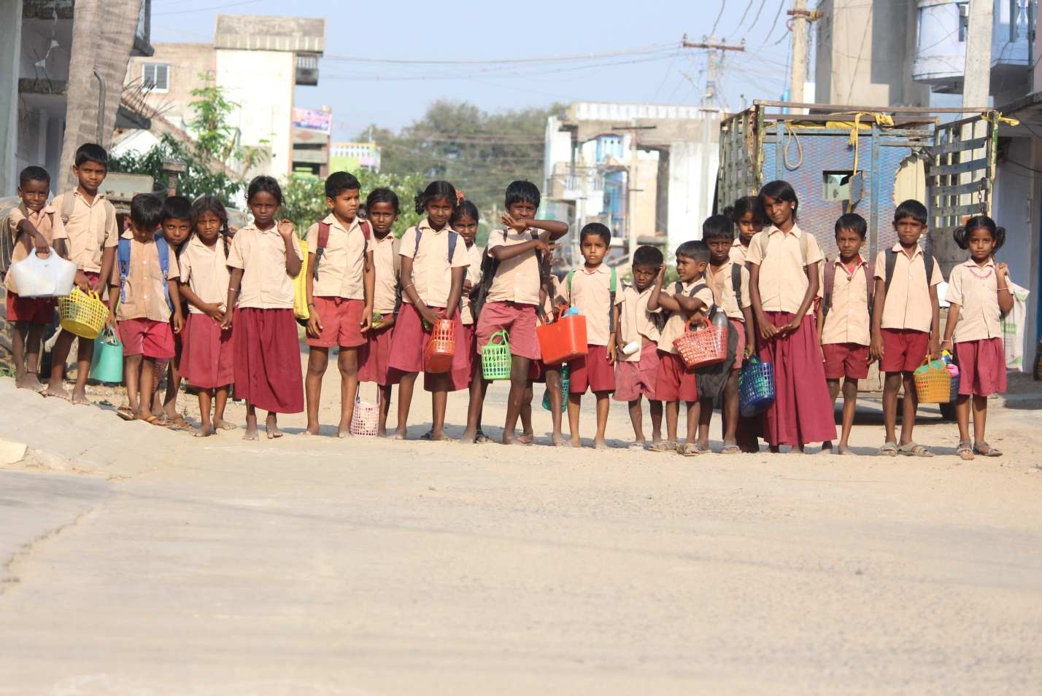

Fig 14: Children returning from school; source: self

* Labour

Cheap labour and strong entrepreneurial skills have always been the backbone of the Indian Apparel and textile Industry.

* Flexibility

The small size of manufacturing which is predominant in the apparel industry allows for greater flexibility to service smaller and specialized orders.

* Rich Heritage

The cultural diversity and rich heritage of the country offers good inspiration base for designers.

* Domestic market

Natural demand drivers including rising income levels, increasing urbanisation and growth of the purchasing population drive domestic demand.

* Government

The government supplies free electricity and raw materials to the weavers of Thirumalpur. Free electricity of 750 units is provided to the power looms. Air jet power looms are also given free of cost to the weavers. There is negligible wastage in weaving process and this wastage too is compensated by the government, and hence they suffer to economic loss. Production cost is very low since the government takes care of raw materials and electricity. The loans and subsidies provided to them are beneficial in long term.

WEAKNESS

* Their financial instability can be considered as their weakness. Due to this they lack many facilities and being not much literate is also one of their weakness as they easily get trapped in the non profitable schemes. While taking a loan when the money gets dissolved in between it’s difficult for them to find the role of the middlemen. Other factors include-
* Lack of infrastructure and communication facilities.
* Unawareness about international requirements and market.
* Lack of co-ordination between government bodies and private institutions.
* Inadequate information of new technology. Inadequate information of current market trends.
* Less interest of young people in craft industry.
* Lack of skilled labour.
* Still confined to rural areas and small cities and untapped market.
* Lack of promotion of products.

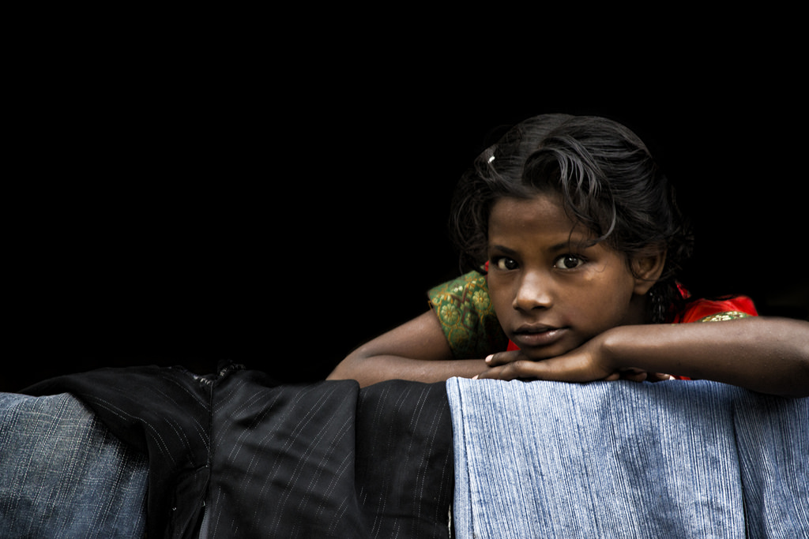

Fig 14: A girl sitting outside her house sunk in deep thoughts; source: self

OPPORTUNITIES

Since Thirumalpur is known for weaving, they get a special attention for the government. Government always tries to provide the people of Thirumalpur with special schemes and programmes. As after the independence, ‘The Weaver’s Policy’ was given priority. They get free electricity for the looms, – 750 watts for the power loom and 100 watts for the handloom – water supply, proper roads and street lights. Other opportunities include-

* Rising demand for handicraft products in developed countries.
* Developing fashion industry requires such products.
* Development of domestic and international tourism sector.
* Expanding range of products to meet broader range of customer needs.

THREAT

Basically, weavers in Thirumalpur receive a great threat from the advanced weaving technology, which tends to be faster, cheaper and easily available to the costumers these days. Due to lack of information and money it is turning out to be very difficult for them to compete with the global market. Apart from this, their designs are not modern so costumers are not interested in purchasing their products.

1. **REFERENCES**

* Dr. R. Jayavel, (2013, April 3). *Blow of textile industry on member weavers’ of silk handloom co-operative societies in kanchipuram district.* Retrived from http://indianresearchjournals.com/pdf/APJMMR/2013/April/3.pdf
* K.K.S.S.R.Ramachandran, (2014, December). *Handlooms and textiles*. Retrived from http://cms.tn.gov.in/sites/default/files/documents/HHTK_handlooms_textiles_0_0.pdf
* Press Information Bureau, ( 2016, June 29), *Mudra scheme for handloom sector.* Retrived from http://pib.nic.in/newsite/PrintRelease.aspx?relid=146603
* *Revised Tariff rates with effect from 23.05.2016 payable by the Consumer,* (2014, December 11). Retrieved from http://www.tangedco.gov.in/linkpdf/ONE_PAGE_STATEMENT.pdf
* *Thirumalpur Handlooms* (n.d.) retrived from http://handloomcluster-wsc-sz.in/Tirumalpur/activities.htm
* *The Geographical Indication Of Goods Act, 1999 (2004, October 6).* Retrived from http://ipindiaservices.gov.in/GI_DOC/15/15%20-%20Form%20GI-1%20-%2007-10-2004.pdf
* M. Soundariya, (2016, August 3). *Now, order your Kancheepuram sarees online straight from weavers.* Retrived from http://www.thehindu.com/business/Industry/Now-order-your-Kancheepuram-sarees-online-straight-from-weavers/article14549114.ece
* B. Bowonder and JV Sailesh. (2016, March 17). *A case study of Kancheepuram Silk Saree.* Retrived from http://planningcommission.nic.in/reports/sereport/ser/stdy_ict/7_kanchee.pdf